**Perform facing operation on shaper machine to calculate Machining Time.**

**Apparatus:**

Shaper machine, vernier caliper, Aluminum slab.

**Apparatus:**

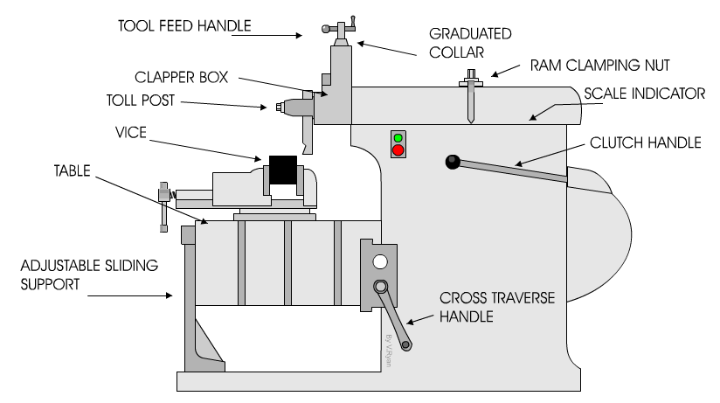

**Theory**

**Shaper Machine**

The shaper is a machine tool used primarily for:

1. Producing a flat or plane surface which may be in a horizontal, a vertical or an angular plane.

2. Making slots, grooves and keyways

3. Producing contour of concave/convex or a combination of these

**Working Principle**

The reciprocating motion of the ram is obtained by a quick return motion mechanism. As the ram reciprocates, the tool cuts the material during its forward stroke. During return, there is no cutting action and this stroke is called the idle stroke. The forward and return strokes constitute one operating cycle of the shaper.

**Construction**

The main parts of the Shaper machine is Base, Body (Pillar, Frame, Column), Cross rail, Ram and tool head (Tool Post, Tool Slide, Clamper Box Block).

**Base**

It is the main body of the machine. It consist all element of machine. It works as pillar for other parts. Base is made by cast iron which can take all compressive loads.

**Ram**

It is the main part of the shaper machine. It holds the tool and provides the reciprocating motion to it. It is made by cast iron and move over ways on column. It is attached by the rocker arm which provide it motion in crank driven machine and if the machine is hydraulic driven it is attached by hydraulic housing.

**Tool head**

It is situated at the front of the ram. Its main function is to hold the cutting tool. The tool can be adjusted on it by some of clamps.

**Table**

It is the metal body attached over the frame. Its main function is to hold the work piece and vice over it. It has two T slots which used to clamp vice and work piece over it.

**Clapper box**

It carries the tool holder. The main function of clapper box is to provide clearance for tool in return stock. It prevents the cutting edge dragging the work piece while return stock and prevent tool wear.

**Column**

Column is attached to the base. It provides the housing for the crank slider mechanism. The slide ways are attached upper section of column which provide path for ram motion.

**Cross ways**

It consist vertical and horizontal table sideways which allow the motion of table. It is attach with some cross movement mechanism.

**Stroke adjuster**

It is attached below the table. It is used to control the stroke length which further controls the ram movement.

**Cutting Parameters**

**Cutting Speed**

The cutting speed of a shaper is the speed at which the metal is removed by the cutting tool in one minute. In other words, only the forward cutting stroke is considered. The speed is expressed in metre per minute. Cutting speed is given as

Vs=NLs(1+m)

N=Number of strokes

Ls=Length of stroke

m=ratio of return to forward stroke

**Feed**

Feed is the relative movement of the work or tool in a direction perpendicular to the axis of reciprocation of the ram per double stroke. It is expressed in mm per stroke.

**Depth of Cut**

Depth of cut is the thickness of metal that is removed during machining. The perpendicular distance measured between the machined surface and the uncut surface of the workpiece is taken. It is expressed in mm or in inches

**Machining Time**

It is time require by shaper machine to complete desire work an is calculated as

Maching Time(Th)= $\frac{w}{fXN}$ xNp

f=Feed

w= width of workpiece

Np=No of Passes

**Procedure**

* Adjust workpiece in vise and adjust stroke length
* Measure feed and depth of cut
* Adjust No of stroke to 40
* By using stop watch measure calculate actual machining time

**Observations & Calculations**

Return stroke time\ Cutting stroke time =m…………………..

Clearance Length=C=…………………………………………..

Initial Thickness of workpiece=ti=…………………………….

Final Thickness=tf=……………………………………………

Depth of cut=d=………………………………………………..

No.of passes=Np=ti-tf\d=

|  |  |  |  |  |  |  |  |  |
| --- | --- | --- | --- | --- | --- | --- | --- | --- |
| Sr.No | Length of workpiece  (L) | Width of workpiece  w | Length of stroke  (Ls=L+2C) | No.of stroke per Mint  N | Cutting speed  Vs=NLs(1+m) | Feed  F=Width of material cut in 1 sroke | Machine Time(Th)= $\frac{w}{fXN}$ xNp | Machining Time (Actual) |
|  | mm | mm | mm |  |  | mm\stroke | min | min |
| **1.** |  |  |  |  |  |  |  |  |
| **2.** |  |  |  |  |  |  |  |  |
| **3.** |  |  |  |  |  |  |  |  |

**Questions**

How to change forward and reverse stroke ratio?

_________________________________________________________________________________________________________________________________________________________________________________________________________________________________

What is difference between right and left handed shaper machine tool?

_________________________________________________________________________________________________________________________________________________________________________________________________________________________________

How to adjust ram stroke length?

_________________________________________________________________________________________________________________________________________________________________________________________________________________________________

What is difference between shaper and slotting machine?

_______________________________________________________________________________________________________________________________________________________________________________________________________________________________________________________________________________________________________________________________________________________________________________________

**Comments on**

How to improve experimental procedure?

**_______________________________________________________________________________________________________________________________________________________________________________________________________________________________________________________________________________________________________________________________________________________________________________________**